**Module (CSS and CSS 3)**

**Q-1 - What are the benefits of using CSS?**

**ANSWER –**

**CSS saves time −** you can write CSS once and then reuse the same Sheet in multiple HTML pages. You can define a style for each HTML element and apply it to as many Web pages as you want.

**Easy maintenance −** To make a global change, simply change the style, and all elements in all the web pages will be updated automatically.

**Global web standards −** Now HTML attributes are being deprecated and it is being recommended to use CSS. So it's a good idea to start using CSS in all the HTML pages to make them compatible with future browsers.

**Platform Independence −** The Script offer consistent platform independence and can support latest browsers as well.

**Q-2 - What are the disadvantages of CSS?**

**ANSWER –**

CSS, CSS 1 up to CSS3, result in creating of confusion among web browsers.

With CSS, what works with one browser might not always work with another. The web developers need to test for compatibility, running the program across multiple browsers.

After making the changes we need to confirm the compatibility if they appear. The similar change effects on all the browsers.

The programming language world is complicated for non-developers and beginners. Different levels of CSS i.e. CSS, CSS 2, CSS 3 are often quite confusing.

CSS works differently on different browsers. IE and Opera supports CSS as different logic.

**Q-3 - What is the difference between CSS2 and CSS3?**

**ANSWER –**

CSS2 which was comprised of a single document.

CSS3 has its specifications divided into many individual modules, which makes CSS3 a whole lot easier to handle. With CSS3, the designers can now use special fonts, like those available in Google Fonts and Typecast.

**Q-4 - Name a few CSS style components.**

**ANSWER –**

The components of css style are:   
1) Selector: HTML element name, id name, class name.

**EXAMPLE**

<!-- example of element name -->

    <p></p>

    <h1></h1>

    <h2></h2>

    <body></body>

    <!-- example of id -->

    <p id="name"></p>

    <!-- example of class -->

    <p class="name"></p>

2) Property: It’s like an attribute such as background color, font-size, position, text-align, color, border etc.

**EXAMPLE**

 <p style="background-color: aqua;"></p>

    <p style="height: 100px;,width: 100px;"></p>

    <p style="position: relative;"></p>

    <p style="font-size: large;"></p>

3) Values: which defines property or values allocate for properties.

**EXAMPLE**

Color value is rgb,rgba.

Height and width value is px, vh and % of size.

Font size value is small,medium,large.

**Q-5 - What do you understand by CSS opacity?**

**ANSWER –**

To set the opacity of a background, image, text, or other element, you can use the CSS opacity property. Values for this property range from 0 to 1. If you set the property to 0, the styled element will be completely invisible. If you set the property to 1, the style element will be completely visible.

**EXAMPLE**

 <!-- opacity 0 means unvisible -->

    <div style="opacity: 0;"></div>

    <!-- opacity 0.5 means light visible -->

    <div style="opacity: 0.5;"></div>

    <!-- opacity 1 means  visible -->

    <div style="opacity: 1;"></div>

**Q-6 - How can the background color of an element be changed?**

**ANSWER –**

Background color propery apply in css to change color.

**EXAMPLE**

<div style="background-color: brown;"></div>

**Q-7 - How can image repetition of the backup be controlled?**

**ANSWER –**

To control the repetition of an image in the background, use the background-repeat property. You can use no-repeat value for the background-repeat property if you do not want to repeat an image, in this case, the image will display only once.

**EXAMPLE**

<!-- when image is small and div is big so image is repete but its not repete use this property -->

    <img src="" alt="" style="background-repeat: no-repeat;,background-size: cover;">

**Q-8 - What is the use of the background-position property?**

**ANSWER –**The background-position property sets the starting position of a background image. a background-image is placed at the top-left corner of an element, and repeated both vertically and horizontally.

**EXAMPLE**

 <style>

        div{

            background-position: center;

            background-position: top;

            background-position: bottom;

            background-position: left;

            background-position: right;

            background: 50% 50%;

        }

    </style>

**Q-9 - Which property controls the image scroll in the background?**

**ANSWER –**

**Background-attachment** property use to image scroll.

**EXAMPLE**

 <style>

        div{

           background-image: url();

           background-repeat: no-repeat;

           background-size: cover;

           background-attachment: scroll;

        }

    </style>

**Q-10- Why should background and color be used as separate properties?**

**ANSWER –**

The background-color property sets the background color of an element. The background of an element is the total size of the element, including padding and border. a color that makes the change text color for easy to read.

<div style="background-color: brown;"></div>

    <div style="color: blue;" ></div>

**Q-11. How to center block elements using CSS1?**

**ANSWER –**

There are two ways to centering block level element.

1. We can use the margin left and margin right Tag.

2. Block level element direct align in center.

**EXAMPLE**

 <style>

        /* center block using margin and padding */

        div{

          margin-left: 100px;

          margin-top: 100px;

        }

         /* center block using aling center */

         div{

            align-items: center;

         }

    </style>

**Q-12- How to maintain the CSS specifications?**

**ANSWER –**

The Specifications defines how CSS Properties should be Implemented by browsers along with detained algorithms, Code sample tabular.

**Q-13- What are the ways to integrate CSS as a web page?**

**ANSWER –** There are three way to integrate CSS as a web page.

1. Inline : HTML element may have CSS applied to them via the style attributes.

<p style="background-color: rgba(116, 8, 22, 0.548);"></p>

2. Internal : with an internal file that you link to in your Webpage.

<head>

    <meta charset="UTF-8">

    <meta http-equiv="X-UA-Compatible" content="IE=edge">

    <meta name="viewport" content="width=device-width, initial-scale=1.0">

    <title>Document</title>

   <!-- internal stylesheet -->

   <style>

    </style>

</head>

3. External : The most Common way to add CSS in external CSS. En external style sheet is a Separate file where you can declare all Files.

<head>

  <link rel="stylesheet" href="sheet.css">

</head>

**Q-14- What is embedded style sheets?**

**ANSWER –**

Internal Style sheet known as a embedded style sheet. Place your CSS rules into an HTML document using the <Style> element that called embedded style Sheet.

<p style="background-color: rgba(116, 8, 22, 0.548);"></p>

**Q-15- What are the external style sheets?**

**ANSWER –**

An external style is a separate file where you can declare all the style that you want to use on your website. External style sheet generally Use when you want to make changes on multiple pages.

<head>

  <link rel="stylesheet" href="sheet.css">

</head>

**Q-16- What are the advantages and disadvantages of using external style sheets?**

**ANSWER –**

**Advantage of external style sheet are: -**

1. External style can be reused across multiple pages and website.
2. External style can be saving time and making it easier to maintain consistence website look.
3. One change to the style sheet will change all linked pages.

**Disadvantage of External sheet are:-**

1. Style sheet format things slightly differently on different browsers.
2. When you uploading and linking to multiple CSS files can increase your sites download time.
3. Your pages may not be remanded correctly until the External CSS is loaded.

**Q-17- What is the meaning of the CSS selector?**

**ANSWER –**

A CSS selector is the first part of a CSS Rule. It is a pattern of elements and other terms that tell the browser which HTML elements should be selected to have the CSS property values inside the rule applied to them.

**Q-18- What are the media types allowed by CSS?**

**ANSWER –**

Desktop styles (not in a media query)

Tablet styles (max-width: 768px)

Mobile styles (max-width: 414px)

**Q-19- What is the rule set?**

**ANSWER –**

A CSS rule set contains one or more selectors and one or more declarations. The selector(s), which in this example is h1 , points to an HTML element. The declaration(s), which in this example are color: blue and text-align: center style the element with a property and value.

**Q-20- Create Layouts**

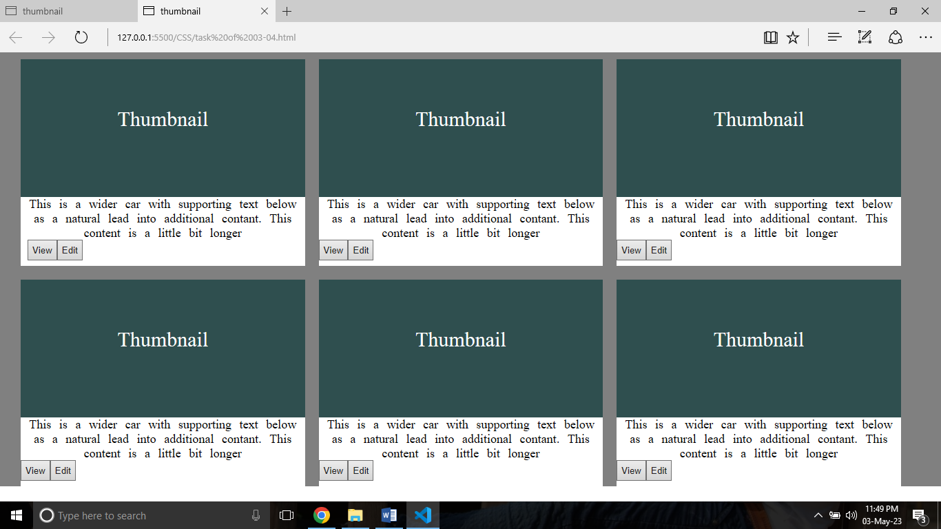

**Html and CSS code**

<!DOCTYPE html>

<html lang="en">

<head>

    <meta charset="UTF-8">

    <meta http-equiv="X-UA-Compatible" content="IE=edge">

    <meta name="viewport" content="width=device-width, initial-scale=1.0">

    <title>thumbnail</title>

    <style>

        /* universal selector */

        * {

            margin: 0px;

            padding: 0px;

            box-sizing: border-box;

        }

        .body {

            height: 630px;

            width: 100%;

            background-color: gray;

        }

        /* divison start  */

        .main {

            height: 600px;

            width: 95%;

            margin: 0 10px 0 30px;

        }

        .main1 {

            height: 300px;

            width: 100%;

            justify-content: space-between;

            display: flex;

            margin-bottom: 20px;

        }

        .main2 {

            height: 300px;

            width: 100%;

            display: flex;

            justify-content: space-between;

        }

        .main11 {

            height: 300px;

            width: 33%;

            margin-top: 10px;

            margin-right: 20px;

        }

        .main111 {

            height: 200px;

            width: 100%;

            background-color: darkslategrey;

        }

        .main112 {

            height: 100px;

            width: 100;

            background-color: white;

            word-spacing: 7px;

        }

        li {

            list-style: none;

          text-align: center;

            color: white;

            font-size: 30px;

            padding-top: 70px;

        }

        .one {

            list-style: none;

            color: black;

            font-size: large;

            text-align: center;

        }

        /* division end */

        /* button start */

        button {

            padding: 5px;

           margin: 0 -11px 0 0 ;

        }

         /* button end */

    </style>

</head>

<body>

    <!-- main divison start -->

    <section class="body">

        <section class="main">

            <!-- division 1 -->

            <div class="main1">

                <div class="main11">

                    <!-- subdivison 1 -->

                    <div class="main111">

                        <li>Thumbnail</li>

                    </div>

                     <!-- subdivison 2 -->

                    <div class="main112">

                        <p class="one">This is a wider car with supporting text below as a natural lead into additional

                            contant. This content is a little bit longer </p>

                        <button style="margin-left: 10px;">View</button>

                        <button>Edit</button>

                    </div>

                </div>

                 <!-- subdivison 1 -->

                <div class="main11">

                    <div class="main111">

                        <li>Thumbnail</li>

                    </div>

                    <!-- subdivison 2 -->

                    <div class="main112">

                        <p class="one">This is a wider car with supporting text below as a natural lead into additional

                            contant. This content is a little bit longer </p>

                        <button>View</button>

                        <button>Edit</button>

                    </div>

                </div>

                <!-- subdivison 1 -->

                <div class="main11">

                    <div class="main111">

                        <li>Thumbnail</li>

                    </div>

                     <!-- subdivison 2 -->

                    <div class="main112">

                        <p class="one">This is a wider car with supporting text below as a natural lead into additional

                            contant. This content is a little bit longer </p>

                        <button>View</button>

                        <button>Edit</button>

                    </div>

                </div>

            </div>

              <!-- division 2 -->

            <div class="main2">

                <div class="main11">

                    <!-- subdivison 1 -->

                    <div class="main111">

                        <li>Thumbnail</li>

                    </div>

                    <!-- subdivison 2 -->

                    <div class="main112">

                        <p class="one">This is a wider car with supporting text below as a natural lead into additional

                            contant. This content is a little bit longer </p>

                        <button>View</button>

                        <button>Edit</button>

                    </div>

                </div>

                <div class="main11">

                    <!-- subdivison 1 -->

                    <div class="main111">

                        <li>Thumbnail</li>

                    </div>

                    <!-- subdivison 2 -->

                    <div class="main112">

                        <p class="one">This is a wider car with supporting text below as a natural lead into additional

                            contant. This content is a little bit longer </p>

                        <button>View</button>

                        <button>Edit</button>

                    </div>

                </div>

                <div class="main11">

                      <!-- subdivison 1 -->

                    <div class="main111">

                        <li>Thumbnail</li>

                    </div>

                    <!-- subdivison 2 -->

                    <div class="main112">

                        <p class="one">This is a wider car with supporting text below as a natural lead into additional

                            contant. This content is a little bit longer </p>

                        <button>View</button>

                        <button>Edit</button>

                    </div>

                </div>

            </div>

        </section>

    </section>

</body>

</html>